Printing Frozen Slide Labels
Accession the case for a frozen as normal. Refer to the guide if needed. *use frozen sentinel breast if indicated
Once the block has printed- exit Accession Entry/Edit
From the Application Manager (Main) Page click on FROZEN (must be added by IT)
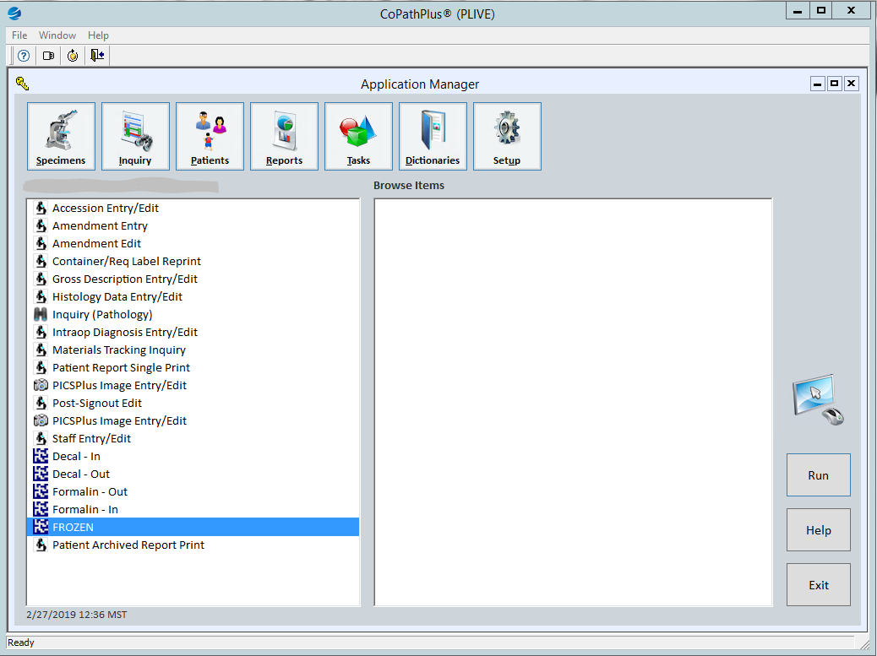
Scan your block. The slides will all have blue check marks beside them. Uncheck H&E.
Click on Save & Label Slides on the bottom right.
Pick up stickers by printer in accessioning area.
Adding an additional block to a frozen (A2, A3..etc)
In Accession Entry/Edit, Histology tab, make sure blue arrow is next to correct part type.
In the bottom left box add 2FS under Blk/Desig, choose white, and add FS under Other Block Number.
In the bottom right box, add “Frozen section, initial” and “Frozen section, each additional” in Stain/Process and change the Blk/Desig to _FS.

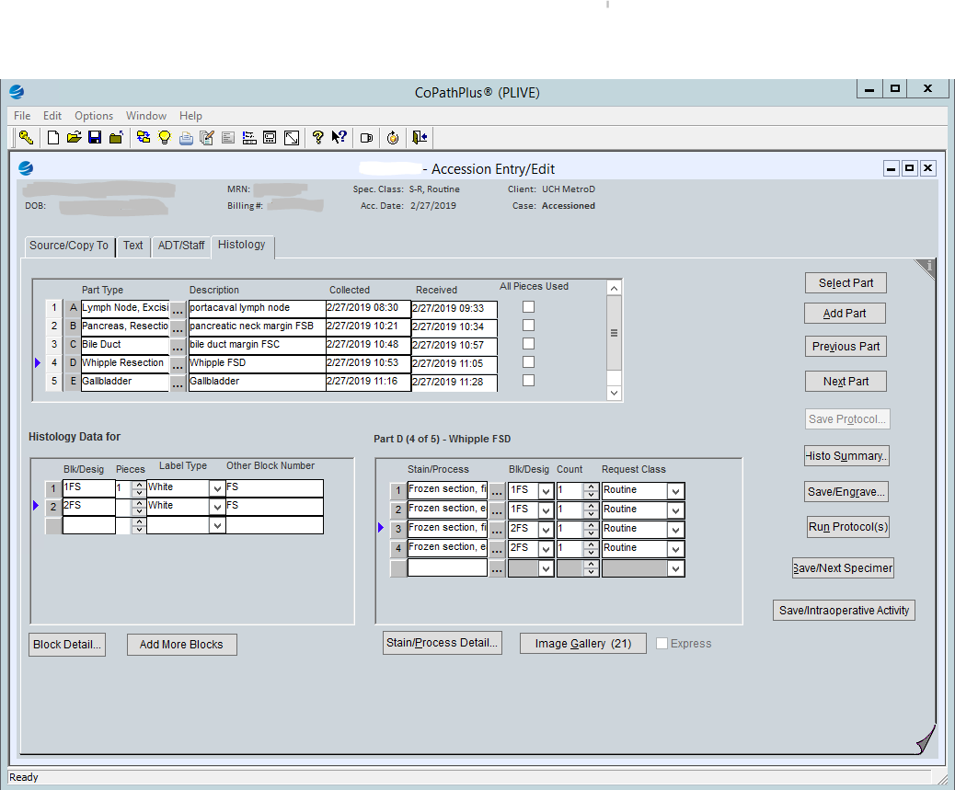
Click Save/Engrave. This will ONLY print your block.
Once you have a block refer to the top of this document to print the stickers.
Adding an additional (deeper) slide to an existing frozen block
From the Accession Entry/Edit, Histology tab make sure the blue arrow is next to the correct part type.
In the bottom left box make sure the blue arrow is by the correct block.
In the bottom right box click an open area and add “Frozen section, each additional” in Stain/Process and hit save.
Exit out of Accession Entry/Edit and double click “FROZEN”
Scan the block and the third slide should have a blue check mark beside it (uncheck any other slides that may have a blue checkmark).
Click Save & Label Slides. Pick up additional sticker(s) in accessioning area.
Neuro frozen
Choose the frozen neuro protocol at accessioning and it will print one frozen slide and one touch prep slide.

If a frozen gets CANCELLED OR CHANGED TO INTRA-OP
Tell lab aides, gross techs or PAs that this change has been made and the frozen needs to be cancelled/changed and give them the cassette (the slides can be thrown away).
If on weekend/on call time- leave a note for Monday morning or email IT for assistance.

